JavaScript Interview Questions

1. JavaScript is synchronous and single-threaded language => executes the single line at a time and once it gets over, it will switch to the next line.
2. Function Statement – Example

function a(){

    console.log("a called");

}

1. Function Expression – function used as values. It can be with or without name. With Function name is known as named function expression.

var b = function b(){

    console.log("b called");

}

1. Anonmyous Function – Function without any name and it can be used only as values as above, because it is not having any name.

function (){

    console.log("b called");

}

1. Named Function Expression – Function Expression with name is named function expression.

As in 2), b is the name and it is called named function expression.

1. Parameter – in the method, arguments are used in the call of the function
2. FirstClass Fucntion/FirstClassCitizens – The ablitiy in which function is used as values, passed as arguments and also return function

var b = function (param){

    return function xyz(){

    }

}

console.log(b());

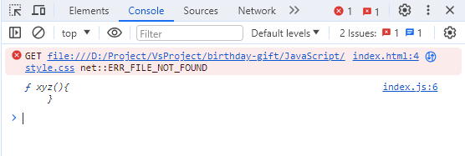

1. CallBack Function – function which passed as arguments, used as async operations using setTimeout()

function x(y){

    console.log("x called");

    y();

}

x(function y(){

    console.log("y called");

});

1. Event Listeners are heavy. Nobody know when a button clicks, so it keeps in memory. It needs to be garbage collected.

function addClickEvent(){

    let count =0;

    document.getElementById("clickEvent").addEventListener("click",function(){

        console.log("Button Clicked", ++count);

    });

}

addClickEvent()

1. setTimeOut(function(){},5000) function, In the Web API, the call back method gets registered. When the timer got expired, the call back function goes to call back queue and the event loop checks if anything in the callback queue, if it is there then it pushes into CallStack
2. Event Loop: continuously listens the call stack and call back queue.
3. Microtask Queue: higher priority queue than callback queue. All the callback function from the promises and mutation observer goes to microtask queue. Mutation Observer observes continuously whether dom is mutated or not.
4. Higher Order Function – Function which is passed as an argument to another function or return function.
5. Map – to get new array out of original array
6. Filter – to get some array values from the list of array values
7. Reduce – takes all values of array and return only single value from it using some logic.
8. CallBack Hell – a callback function within callback function (pyramid of doom)

const cart = ["shoes", "shirts"]

api.createOrder(cart, function(){

    api.proceedPayment();

});

1. Inversion of Control – giving control to the program. In the above program, proceedPayment() is in the control of createOrder api. So this is issue with callback. It can be handled by **promises**.
2. Promise – empty object initially, after createOrder api returns some values and that is captured in promises.

A container for the future value.

Promise is an object representing the eventual completion or failure of an async operation.

const promise = createOrder(cart);

// Initially promise = {data: undefined}

// after some secs createOrder api returns orderID

// promise {data : orderId}

promise.then(function(){

    proceedPayment();

});

1. Fetch() – to call api to make external calls.
2. Promise contains two things

PromiseType – pending(initial step) , fulfilled(data returned), rejected(data not returned)

PromiseResult – contains the entire reponse as json object.

function createOrder(cart){

    const pr  = new Promise(function (resolve, reject){

        if(!isValidCart(cart)){

            const err =  new Error("Cart is not full");

            reject(err);

        }

        const orderId = "abc123";

        if(orderId){

            resolve(orderId);

        }

    });

    return pr;

}

1. Promise chain – promise contains another promise.
2. Promise Api’s,

* Promise.all() – It contains arrays of promises. If all promises are success, it will wait for the last one and return success , of all the arrays[val1,val2,val3]. If anyone fails, then it immediately return failure irrespective of others and won’t wait of other promises.
* Promise.allSettled() - Array of Promises. If all success, then it will return fulfilled of all arrays as promise.all(). If anyone fails, it will wait for other promises and return all the results. If array is of 3 promises, then output will be [val1, err2, val3]
* Promise.Race() - Array of promises. [p1,p2,p3] when all success. Whichever finishes first, it will return that value. If any promises settled with error , it will return the error , it considers for time only.
* Promise.Any() – It will wait for the first success and return it. If all fails, it will return aggregate error[err1,err2,err3].

1. Async() function – always return promise. If string is returned manually, it will automatically wraps into Promise and return it.

const pro = new Promise(function(resolve, reject){

    resolve("Resolved");

});

async function getData(){

    return pro;

}

const dataPromise = getData();

console.log(dataPromise);

dataPromise.then(function(resp){

    console.log(resp);

});

1. Await() function – needs to use await keyword infront of promise. Await keyword only inside async function().

const pro = new Promise(function(resolve, reject){

    resolve("Resolved");

});

async function getData(){

    const usingAwait = await pro;

    console.log(usingAwait);

}

getData();

// const dataPromise = getData();

// console.log(dataPromise);

// dataPromise.then(function(resp){

//     console.log(resp);

// });

1. Fetch() – gives to return promise. When promise is resolved, it will return response object. To convert this response (readable stream) to json.

const API_URL = "https://api.github.com/users/Mukeshraj94";

async function getData(){

   const data = await fetch(API_URL);

   const jsonVal = await data.json();

   //fetch => reponse.json => jsonVal

}

getData();

1. Exception handling –

async function getData(){

    try {

        const data = await fetch(API_URL);

        const jsonVal = await data.json();

        //fetch => reponse.json => jsonVal

        console.log(jsonVal);

    } catch (error) {

        console.log(error);

    }

}

getData();

1. Async await Vs Promise.then/catch – async internally uses then/catch. If async is used, only after promises return something, then only next line will execute.
2. This keyword scopes.

* In Global Space – “this” keyword returns global object as “window” in browser, “global” in nodejs.
* Inside function () – In strict mode, it is undefined. In non-strict mode, “this” substitution happens and became global object.
* This inside object’s method – value of “this” keyword is object.
* In arrow function – enclosing lexical context.
* In DOM elements – it reference to particular html dom element.

Java Interview Question

1. For Setting environment variables, copy the path “C:\Program Files\Java\jdk-17\bin” where java compiler installed.
2. JDK = JDK + JRE(contains compiler and support libraries) + JVM(byte code will execute)
3. JRE = JRE + JVM
4. JVM = Stack Memory + Heap Memory(has String constant pool)
5. Stack Memory = contains local variable and methods.
6. Heap Memory = contains object and global variables.
7. Array – Collection of objects

    int arr[] = new int[3]; // fixed array

    int arr1[][] = new int[4][5]; //multi dimensional array

    int arr2[][] = new int[4][]; //jagged array - column can be different

    arr2[0] = new int[1];   //First row with 1 column

    arr2[1] = new int[2];   //Second row with 2 columns

    arr2[2] = new int[3];   //Third row with 3 columns

    arr2[3] = new int[4];   //Fourth row with 4 columns

1. Static variable – common for all the objects
2. Static block – called only once and it will be the first one to call before constructor.
3. Anonymous object – object created without any reference variable.

new Demo();

1. For Inheritance, even if .java is not present, the extended .java will inherit. Only, .class file is enough.
2. Ambiguity Problem – Multiple inheritance is not supported in java. Two parents may have same method name. In that case, child class get confused which to choose. For this, interface is used.
3. By default, every constructor has super.

class Demo{

    public Demo(){

        super();//by default

    }

}

class B extends A{

    public B{

        System.out.println("B called");

    }

}

1. Every class in java extends Object class.
2. this(), will call constructor of the current class.

class Demo{

    public Demo(){

        super();//by default

    }

}

class B extends Demo{

    public B(){

        System.out.println("B called");

    }

    public B(int a){

        this();// it will call B()

        System.out.println("B parametrized called");

    }

}

1. Dynamic method dispatch happens in polymorphism (many forms )

    A a= new A();

    a.show();

    a = new B();    //different forms

    b.show();

1. By default, .equals() compares two objects with hashcode
2. Equals(), will check only the reference object.
3. UpCasting and Downcasting

A obj= new B(); // implicitly Upcasting

    a.show1();

    B b = (B) obj;    // Downcasting

    b.show2();

1. Wrapper class – Integer, Double, Character. All primitive type has wrapper class. In int-> Integer.

    int num = 7;

    Integer num1 = num; // AutoBoxing - primitive type to wrapper class

    int num2 = num1;    //Auto-unboxing - wrapper class to primitive type

1. For abstract class, not able to create object. But object can be created with the help of Anonymous Inner Class(class with no name).

abstract class A{

    public abstract void show();

}

public class Main{

    public static void main(String[] args) {

       A a = new A() {

        public void show(){

            System.out.println("new show");

        }

       };

       a.show();

    }

}

1. Types of Interface: Normal, Functional interface or SAM(Single Abstract Method) – FI contains only one abstract method and Marker interface – no abstract method (useful for resuming videos)
2. FI – only one abstract method

@FunctionalInterface

interface A{

    void show();

}

public class Main{

    public static void main(String[] args) {

       A a = new A() {

        public void show(){

            System.out.println("new show");

        }

       };

       a.show();

    }

}

1. Lambda Expression – useful for FI

@FunctionalInterface

interface A{

    void show();

}

public class Main{

    public static void main(String[] args) {

       A a = () -> System.out.println("new show");  //lambda expression

       a.show();

    }

}

See 23 for better understanding.

1. Exceptions are runtime error.
2. explicity throw Exception using throw keyword
3. throws means that particular class not responsible but the parent has to handle the exception.
4. Buffered reader works with resources and it needs to be closed while after using it.

InputStreamReader in = new InputStreamReader(System.in);

      BufferedReader bf = new BufferedReader(in); // we can read data from user or read file,etc and other resources

      Scanner sc = new Scanner(System.in);

      try {

        System.out.println("Enter input:");

        int s = Integer.parseInt(bf.readLine());

        System.out.println("Entered Value:"+s);

      } catch (IOException e) {

        // TODO Auto-generated catch block

        e.printStackTrace();

      }

1. Finally is used for closing resources.it will execute even if there is no catch block. Whatever it may throw exception, finally will execute.

finally{

bf.close();

      }

1. For Optimal usage of closing resources, we use try with resources,

try (BufferedReader bf = new BufferedReader(new InputStreamReader(System.in)))

      {

        System.out.println("Enter input:");

        int s = Integer.parseInt(bf.readLine());

        System.out.println("Entered Value:"+s);

      } catch (IOException e) {

        e.printStackTrace();

      }

1. For class to use thread, it can be done by extends Thread or implements Runnable interface.
2. For thread extends, we can call directly using start() with class reference object

class A extends Thread{

  public void run(){

    System.out.println("A called");

  }

}

public class Main{

    public static void main(String[] args) {

      A a = new A();

      a.start();

    }

}

1. For Runnable interface, needs to create object of thread and call them.

class A implements Runnable{

  public void run(){

    System.out.println("A called");

  }

}

public class Main{

    public static void main(String[] args) {

      Runnable a = new A();

      Thread t = new Thread(a);

      t.start();

    }

}

1. Race condition can be eliminated by synchronize keyword in the method, where only one thread can execute that particular method at a time.
2. Collection API (concept),1) Collection(interface), 2) Collections(class) 3) Map
3. Collections – Comparable uses natural sorting order. compareTo(), uses one sort order
4. Collections – Comparator uses our own sorting order. Compare() , for comparing two different objects
5. Parallel Stream will be faster than stream but, don’t use parallel stream when sorting is performed.

Spring Interview Questions

https://github.com/navinreddy20/spring6-course/tree/main/3.1%20Working%20with%20Java-Based%20Config%20(3.1%20to%203.9)

1. IoC- Inversion Of Control principle (giving control to spring container)
2. DI – Dependency Injection is the design pattern to implement Ioc.
3. Spring Core – Dependency injection, Spring MVC – FrontEnd Controller,

Spring REST – Spring ORM -

1. Before Springboot, spring framework will create objects as below,

ApplicationContext context = new ClassPathXmlApplicationContext("spring.xml");

Alien al = (Alien)context.getBean("alien");

al.code();

In Spring.xml, <bean id=”alien” class=”com.mukesh.Alien”></bean>

1. Dependency Injection/ Inversion Of Control – Bean creation and injection will be taken care of the spring core.
2. By default, Spring container will create only one object, it same class object is created once again(Singleton pattern)
3. Prototype, separate object will be created for every new reference object.

<bean id=”alien” class=”com.mukesh.Alien” scope=”prototype”></bean>

1. Setter Injection: using set method, we are setting values

<bean id=”alien” class=”com.mukesh.Alien” scope=”prototype”>

<property id=”age” value=”10”></property>

</bean>

The above code works for only primitive datatype.

For other class reference object, we need to use as follow,

<bean id=”alien” class=”com.mukesh.Alien” scope=”prototype”>

<property id=”age” value=”10”></property>

<property id=”laptop” ref=”laptop”></property>

</bean>

<bean id=”laptop” class=”com.mukesh.Laptop”></bean>

1. Constructor injection- using constructor –arg tag in the xml for setting.

<bean id=”alien” class=”com.mukesh.Alien” scope=”prototype”>

<constructor-arg value=”12”></constructor-arg>

</bean>

1. Autowire – byname will search with “name” of the variable is present or not in that pojo

byType will search with the type of the variables in that pojo.

<bean id=”alien” class=”com.mukesh.Alien” autowire=”byType”>

<property id=”age” value=”10”></property>

<property id=”laptop” ref=”laptop”></property>

</bean>

<bean id=”laptop” class=”com.mukesh.Laptop”></bean>

1. Primary bean – Spring container will give priority to the one which is given with the keyword primary and consider for it, if there are two reference objects are there.

<bean id=”alien” class=”com.mukesh.Alien” autowire=”byType”>

<property id=”age” value=”10”></property>

<property id=”laptop” ref=”laptop”></property>

</bean>

<bean id=”laptop” class=”com.mukesh.Laptop” primary=”true”></bean>

<bean id=”desktop” class=”com.mukesh.Desktop”></bean>

1. Lazy-init – object will be created whenever bean gets called and required and spring container will not do it at the start of the project.

<bean id=”desktop” class=”com.mukesh.Desktop”></bean>

1. Java based configuration is similar to spring.xml based configuration

@Configuration

public class AppConfig {

// @Bean(name = {"Beast","desktop","com1"})

//multiple words can be used for a bean to call

@Bean

public Desktop desktop() {

return new Desktop();

}

}

public class App {

public static void main(String[] args) {

ApplicationContext context = new AnnotationConfigApplicationContext(AppConfig.class);

Desktop dt = context.getBean("desktop",Desktop.class);

dt.compile();

1. @Scope(“prototype”) will be used after @Bean,
2. @Component – seterotype of annotation and has to be mentioned in the class. No need to write the code in 13) like @Bean and other stuffs
3. If we use @Component, then AppConfig there is no code and spring will not understand where to create beans, hence we need to use @Component-Scan to scan the beans

@Configuration

@Component-Scan(“com.mukesh”)

public class AppConfig {

1. @Qualifier has higher precedence than @Primary
2. @Value(“21”) private int age; we are injecting age value with @Value annotations.
3. Lombak jar will take care of getter and setter in pojo class.

@Data – for getter and setter

@NoArgsConstructor – for creating default constructor

@AllArgConstructor – for creating all variables parametrized constructor.

1. Hibernate config dependency jars: hibernate core(for hibernate connection), spring orm(for spring to connect with orm), Spring transaction(for handling transaction), mysql connector(for mysql connection), c3p0 (for handling multiple pooling)
2. Spring.jpa.hibernate.ddl-auto = create/update. Create uses to create new table, update will update the table if present or create new table
3. Spring.jpa.hibernate.show-sql= true. No need to write sql, hibernate will take care.
4. Query DSL (Domain Specific Language)- Query annotation to be used in the Repo class, when our own find logic will be used.

@Query(“select s from Student s where s.name=?1”)

List<Student> findByName(String name);

findByName- method needs to be overridden in the repo class.

SpringBoot Questions

1. Client sends request to server, inside server Controller takes care of request and sends back to request, that is the only job of Controller. After that, Service layer , where business logic will be returned. After that Repository/DAO layer where database related comes into picture. DAO sends data back to service, and service sends back to Controller.
2. @Service – for service layer. It internally calls @Component.
3. @Repository – for Db related function use this. It internally calls @Component.
4. Update() – for insert, update db

private JdbcTemplate jdbc;

public JdbcTemplate getJdbc() {

return jdbc;

}

@Autowired

public void setJdbc(JdbcTemplate jdbc) {

this.jdbc = jdbc;

}

public void save(Student s) {

String sql="insert into student(rollno,name,marks) values(?,?,?)";

int rows=jdbc.update(sql,s.getRollNo(),s.getName(),s.getMarks());

System.out.println(rows);

}

1. For fetching result using spring jdbc,

public List<Student> findAll() {

String sql="select * from student";

RowMapper<Student> mapper=new RowMapper<Student>() {

@Override

public Student mapRow(ResultSet rs, int rowNum) throws SQLException

{ Student s=new Student(); s.setRollNo(rs.getInt("rollno"));

s.setName(rs.getString("name")); s.setMarks(rs.getInt("marks")); return s; }

};

return jdbc.query(sql, mapper);

}

1. @RequestMapping – It will tell the controller to pick the method in which client is requested.
2. Tomcat jasper jar – parses jsp files to compile them into java code as servlets
3. @RequestParam() – for identifying parameter which has been passed from jsp to controller

public ModelAndView add(*@RequestParam*("num1") int i, *@RequestParam*("num2")int j)

1. ModelAndView – contains data and jsp page details.

*@RequestMapping*("/add")

public ModelAndView add(*@RequestParam*("num1") int i, *@RequestParam*("num2")int j) {

ModelAndView mv = new ModelAndView("result");

int num3 = i+j;

mv.addObject("num3",num3);

return mv;

}

1. If we need to configure jsp in different folders, we can configure in the application.properties files. (.jsp) can be made customisable

spring.mvc.view.prefix=/views/

spring.mvc.view.suffix=.jsp

1. Model or ModeAndView can be used , based on our choice.

*@RequestMapping*("/add")

public String add(*@RequestParam*("num1") int i, *@RequestParam*("num2")int j, Model m) {

// ModelAndView mv = new ModelAndView("result");

int num3 = i+j;

// mv.addObject("num3",num3);

m.addAttribute("num3",num3);

return "result";

}

1. ModelAttribute – before using that annotation

public String addAlien(*@RequestParam*("aid") int i, *@RequestParam*("aname")String j, Model m) {

Alien a= new Alien();

a.setAid(i);

a.setAname(j);

m.addAttribute("alien",a);

return "result";

}

After using @modelattribute, it reduces all codes,

*@RequestMapping*("/addAlien")

public String addAlien(*@ModelAttribute*("aliens") Alien a, Model m) {

// public String addAlien(@RequestParam("aid") int i, @RequestParam("aname")String j, Model m) {

// Alien a= new Alien();

// a.setAid(i);

// a.setAname(j);

// m.addAttribute("alien",a);

return "result";

}

1. @ModelAttribute – at method level. Spring will call this method before controller and model gets created and value is assigned.

*@ModelAttribute*

public void modelData(Model m) {

m.addAttribute("name","Alien");

}

Result.jsp

Welcome Back ${name}

</**body**>

1. Whenever, we are sending data to the server, we will use POST. Whenever we are getting data from the server, then we will use GET.

<**form** action=*"addAlien"* method=*"post"*>

*@PostMapping*("/addAlien")

public String addAlien(*@ModelAttribute*("aliens") Alien a) { return "result";

}

1. ORM – Object Relational Mapping. ORM tool internally uses the JDBC Api to interact with the database.
2. Hibernate is a framework that simplifies the development of java application to interact with the database.
3. @Transactional – Inorder start and end the database transaction, need to use it.
4. In order to connect with database, spring data jpa jar required and dao needs to extend Jpa repo. In application.properties, some config is required.

public interface AlienRepo extends JpaRepository<Alien, Integer>{}

spring.datasource.url=jdbc:mysql://localhost:3306/mukesh

spring.datasource.username=root

spring.datasource.password=12345678

spring.jpa.properties.hibernate.dialect=org.hibernate.dialect.MySQLDialect

1. @ResponseBody – at the method level, tells that the method will return json/xml type
2. @Controller + @ResponseBody = @RestController, it tells that the controller will return data in the form of json/xml
3. @Controller , will return the view resolver.
4. @RequestBody – at the parameter level of the method, used to tell that the input from postman(client) is of some data and it needs to be converted into json/xml.
5. Below are for server side to mention that the data is of type json or xml.

*@GetMapping*(path="/aliens",produces= {"application/json"})

public List<Alien> getAliens() {}

*@PostMapping*(path="/alien",consumes= {MediaType.***APPLICATION_JSON_VALUE***})

public Alien postAlien(*@RequestBody* Alien aln) {}

1. By default, java objects from client will be converted into Json with internal jar named as Jackson. But for xml, we need to import Jackson-dataformatter jar to be added.
2. If we have to use that conversion from the produce/consume
3. PathVariable – to mention that the client is getting data with some parameter,

*@GetMapping*("/alien/{aid}")

public Alien getAlien(*@PathVariable* int aid) {}

1. AOP – Aspect Oriented Programming. To achieve modularaisation by logging, transaction, etc.

*@Aspect*

*@Component*

public class LoggingAspect {

private static final Logger ***log*** = LoggerFactory.*getLogger*(LoggingAspect.class);

*@Before*("execution(public * com.example.demo.HomeControllerForRest.getAliens())")

public void getLogBefore() {

***log***.info("Before GetAlien method called");

}

*@After*("execution(public * com.example.demo.HomeControllerForRest.getAliens())")

public void getLogAfter() {

***log***.info("After finally GetAlien method called");

}

*@AfterThrowing*("execution(public * com.example.demo.HomeControllerForRest.getAliens())")

public void getLogAfterThrow() {

***log***.info("After Throw GetAlien method called");

}

*@AfterReturning*("execution(public * com.example.demo.HomeControllerForRest.getAliens())")

public void getLogAfterSuccess() {

***log***.info("After Success GetAlien method called");

}

}

1. DTO Data Transfer Objects – Data will be transferred from controller to service to repo by calling method name with object parameters
2. REST – Representational State Transfer. Just transferring data to the client. Rest is stateless, means everytime client hits server it will be new request. It will not remember, that it has been called early. Rest will deal with resources
3. @CrossOrigin(“http://localhost/jobPosts) - Inorder to connect with different framework like React.
4. Rest Repositories Web – It will create controller and service layer. In project only repo and model class is enough and nothing requires. While getting data from postman api, it will return json along with the “link” which will be used for retrieving.

Java MicroServices:

1. Microservices, handle each service differently.
2. Each service needs to register in the Eureka server.
3. In our case **Service-Registry**, StudentEurekaRegistry is the eureka server, only two dependencies are required,

<dependency>

<groupId>org.springframework.boot</groupId>

<artifactId>spring-boot-starter-web</artifactId>

</dependency>

<dependency>

<groupId>org.springframework.cloud</groupId>

<artifactId>spring-cloud-starter-netflix-eureka-server</artifactId>

</dependency>

1. Below application.properties to be mentioned,

spring.application.name=StudentEurekaRegistry

server.port=8791

eureka.instance.hostname=localhost

eureka.client.fetch-registry=false

eureka.client.register-with-eureka=false

1. Annotation for Eureka server,

*@*SpringBootApplication

*@*EnableEurekaServer

public class StudentEurekaRegistryApplication {

1. **API Gateway**, has to be there in MS , where it will redirect the each service communication and it handles all the service request , similar to dispatchServlet,

spring.application.name=StudentApiGateway

server.port=9000

spring.cloud.gateway.discovery.locator.enabled=true

spring.cloud.gateway.discovery.locator.lower-case-service-id=true

eureka.client.service-url.defaultZone=http://localhost:8791/eureka

1. Two dependencies, eureka client and gateway to be added

<dependency>

<groupId>org.springframework.cloud</groupId>

<artifactId>spring-cloud-starter-gateway</artifactId>

</dependency>

<dependency>

<groupId>org.springframework.cloud</groupId>

<artifactId>spring-cloud-starter-netflix-eureka-client</artifactId>

</dependency>

1. StudentApplication microservice, below client dependency to be added. Feign dependency is for accessing the other microservice(Address)

<dependency>

<groupId>org.springframework.cloud</groupId>

<artifactId>spring-cloud-starter-netflix-eureka-client</artifactId>

</dependency>

<dependency>

<groupId>org.springframework.cloud</groupId>

<artifactId>spring-cloud-starter-openfeign</artifactId>

</dependency>

1. Feign Client annotation to be added,

*@SpringBootApplication*

*@EnableFeignClients*

public class StudentApplication {

1. For to access Address microservice, that can be done by adding that method signature as separate interface,

*@FeignClient*("StudentAddress")

public interface FeignInterface {

*@GetMapping*("/getAddressId/{id}")

public ResponseEntity<Address> getAddressId(*@PathVariable* Integer id);

}

*@*Autowired

FeignInterface fDao;

public ResponseEntity<Address> getAddressId(Integer id) {

// Address addr= aDao.findById(id).get();

Address addr= fDao.getAddressId(id).getBody();

return new ResponseEntity<Address>(addr,HttpStatus.OK);

}

1. Another Microservice Address,

<dependency>

<groupId>org.springframework.cloud</groupId>

<artifactId>spring-cloud-starter-netflix-eureka-client</artifactId>

</dependency>

1. Application.properties,

spring.application.name=StudentAddress

server.port=8090

eureka.client.service-url.defaultZone=http://localhost:8791/eureka

1. Incase if any failure happens in any service, we can use CircuitBreaker which will not stop the service. But it can be used for less risk only, not for payment service.
2. Below dependency to be added for circuit breaker,

<dependency>

<groupId>io.github.resilience4j</groupId>

<artifactId>resilience4j-circuitbreaker</artifactId>

<version>2.1.0</version>

</dependency>

<dependency>

<groupId>org.springframework.boot</groupId>

<artifactId>spring-boot-starter-aop</artifactId>

</dependency>

<dependency>

<groupId>org.springframework.boot</groupId>

<artifactId>spring-boot-starter-actuator</artifactId>

</dependency>

1. Below application.properties to be added,

SlidingWindowSize, is last failure call happened

Failure rate threshold is in %

Duration in open state is in millisecond

If any service failed in closed state (for 10 slidingwindow size) in our case, then it will go into open state for some ms(30000) and the call will not happen during that time. Once after, 30000 ms, it will go into Half-Open state and there is some permitted number of call only will happen(5) . If the failure is < =failure threshold then it will enter into closed state and normal flow happens. If the failure >= failure threshold, then it will again enter into open state.

#resilience properties

resilience4j.circuitbreaker.instances.addressService.sliding-window-size=10

resilience4j.circuitbreaker.instances.addressService.failure-rate-threshold=50

resilience4j.circuitbreaker.instances.addressService.wait-duration-in-open-state=30000

resilience4j.circuitbreaker.instances.addressService.automatic-transition-from-open-to-half-open-enabled=true

resilience4j.circuitbreaker.instances.addressService.permitted-number-of-calls-in-half-open-state=5

#to see the status of the service , need actuator properties along with resilience

resilience4j.circuitbreaker.instances.addressService.allow-health-indicator-to-fail=true

resilience4j.circuitbreaker.instances.addressService.register-health-indicator=true

#properties applicable only to actuator

management.health.circuitbreakers.enabled=true

management.endpoints.web.exposure.include=health

management.endpoint.health.show-details=always

#circuit closed - "UP" in actuator

#circuit open - "DOWN" in actuator

#circuit half-open - "UNKNOWN" in actuator

1. CircuitBreaker is AOP, and It needs to be added separately in the different class as below,

*@Service*

public class AddressAop {

*@Autowired*

FeignInterface fDao;

*@*CircuitBreaker(name="addressService", fallBackMethod="fallBack")

public Address getAddressById(Integer id) {

return fDao.getAddressId(id).getBody();

}

public Address fallBack(Integer id) {

return new Address();

}

}

TCS Interview Questions

1. How to set dev, qa and prod in springboot.
2. How to eliminate some config in springboot
3. Convert json to xml in springboot
4. Controller vs restcontroller
5. What controller returns
6. How to perform parallel operaions in springboot
7. @restcontroller returns?
8. Flatmap in java8
9. Connect db with springboot

Java 8

1. Multiple Inheritance is achieved in JAVA 8 by default methods.

Rule 1- Classes take higher precedence than interfaces –

Rule 2 — Derived interfaces or sub-interfaces take higher precedence than the interfaces higher-up in the inheritance hierarchy-

Rule 3 — In case Rule 1 and Rule 2 are not able to resolve the conflict then the implementing class has to specifically override and provide a method with the same method definition-

1. Lambada is a function without a name. Eg: ()->{}
2. Lambda expression used for implementing FI /SAM
3. Functional Interfaces are only one abstract methods. In java8, below are the FI,

Consumer, Predicate, Function and Supplier.

1. Consumer FI – accept input and perform some operation of the input. It won’t return any values. It will perform some operations
2. Bi Consumer FI – accept two inputs.
3. Predicate – return Boolean and used for the resuse of code.
4. BiPredicate – return Boolean and accepts two parameter.
5. Function – accepts one input and returns one output.
6. Unary Operator – accepts one input and returns one output but both has to be of same return type.
7. Binary Operator – accepts two input and returns one output, Both input and output has to be of same return type.
8. Supplier – it won’t accept input but returns output.
9. Method reference – ClassName::methodName
10. Constructor reference – ClassName::new //not possible for A a = new A();
11. Effectively Final – In Lambda’s, allowed to use local variable but they are not able to change the value of it. Hence, it is known as Effectively Final.
12. Stream API – to perform operations on Collections
13. In stream, cannot add or modify elements and follows sequence retrieval. It will be invoked when the terminal operations are invoked.
14. Stream can be used only once.
15. Peek() – for debugging filter
16. Map () – convert one type to another. This map is different from Collection Map. Input is Function.
17. flatMap – similar to map but it will handle operation with Stream of List/arrays, etc. Whereas map will be Stream of single object.
18. Distinct – return streams of values without duplication
19. Count() – return streams with long values.
20. Sorted() – return streams in natural sorting.
21. Sorted(Comparator) – return stream with our own sorting order.
22. Filter() – filters the stream of elements. Input is predicate
23. Collect() – collect streams as input and Collectors as parameter. It is terminal operation where it is used at the end of the stream.
24. Reduce() – it is also terminal operation. Used to reduce stream of data’s into single value.

Takes two parameter (First param- default or initial value, Second param-Binary operator)

1. Reduce(single param) – it will return Optional class
2. Limit(n) – limit ‘n’ number, even if 10 or many elements are present
3. Skip(n) – skip the particular ‘n’ element
4. anyMatch() – returns true if anyone of the elements matches predicate

allMatch() – return true if all of the elements matches predicate

noneMatch() – return true if none of the elements matches predicate and return false if anyone match is found

1. findFirst() – return the first element as of type Optional
2. findAny() – return the first encountered element as of type Optional.
3. ShortCircuiting – Functions does not have to iterate the whole stream to evaluate the result.

[Limit, (findFirst, findAny), (anyMatch,allMatch,noneMatch)]

1. Stream Operations – Of() – create stream of certain values passed to this method.

Iterate() and generate() – create infinite streams

1. Numeric Streams – for number related operations. In normal stream, Wrapper Class will unbox from Integer to int but numeric stream will do it in the primitive types directly.
2. Range(1,50) – it won’t include last element in that range.

RangeClosed(1,50) – It will include last element in that range

1. Boxing() – convert primitive to wrapper class ex: int to Integer

UnBoxing – convert wrapper class to primitive ex: Integer to int.

1. Terminal operations – used at the last of the stream. And such are,

Foreach, reduce, min,max, collect, etc

1. Groupingby() collector is similar to SQL group by operation. Based on property it will group. Output will be Map<K,V>
2. partioningBy() collector is similar to groupingBy(). Accepts predicate as input and return is Map<K,V> where Key has to be Boolean.
3. Multiple Inheritance is possible in java after java8.
4. LocalDate, LocalTime and LocalDateTime part of java.time package. This is alternate to joda-time library. All these are immutable.
5. Period used for finding difference between two dates. Not able to perform difference operations in Time.
6. Duration is used in the case of time related logics.
7. Instant – represent time in machine readable format. Instant ins= Instant.now();
8. Jan 1,1970 – Epoch
9. Time Zones – Date/Time with its time zone.

**System Design Principles:**

1. Vertical Scaling
2. Preprocessing and Cron job (consider pizza making during non-peak hours)
3. Backups
4. Horizontal Scaling
5. MicroServices architecture
6. Distributed System
7. Load Balancer

* In load balancing, earlier if we use hasing of the request id it will generate some integer and mod of no. of servers, then it will be mapped the request to some place.

Ex: hash(request id 1) = 10 % 5(no of server) =0

* Here request id 1 will be served in Server (s0). Here load balance is 1/N , N-> no of servers
* Likewise other request are handled, but if new servers are added, the denominator to be changed and cache of each server will be lost.
* In order to overcome this scenario, Consistent Hashing gets used.
* Here, it will follow circular way to handle request, the nearer server will handle the request.
* Here load balance is also 1/N but the load will not be shifted to the all other servers, load will be handled to the next server.
* But, if that the case, only one server will handle too much load if there is some nearer server gets crashed.
* So here, K hash function to be used, means if there are 4 servers, then K=3 , then 12 servers will be handled circularly, in which each server will have 3 hashing function and handle the request efficiently.

1. Decoupling
2. Logging and Metrics.
3. Extensibility – no need to code again and again for different resources(Ex: Today delivery agent will deliver pizza, tomorrow they will deliver burger)
4. Scalability – how many server and how big a server can handle request
5. Horizontal Scaling – many resources are available there to handle.

Load balancing required.

Resilient – if one server not available, then other server will take care.

Network calls RPC- each server will communicate between them. Because of this, data inconsistency will be there.

Scales well, when users are more.

1. Vertical Scaling – One big server handles all the request. Due to this,

No load balance is required,

Inter process communication will be faster.

Data will be consistent.

But there is hardware limit.

1. Sharding Database – Sharding means “Splitting db into small chunks of tables”

Partitioned data chunk are logical shards. Machine that stores logical shards are physical shards.

Sharding key – how to partition the dataset

Methods of sharding : Range based sharding(alphabet a to e will have shard key as “A”), Hashed sharding, Directory sharding(if a dress is green, shard key is “A”, for yellow shard key is “B”) and Geo Sharding(shared key will be based on the cities)

Sharding is similar to horizontal partioining but partitioning data will be stored in the same computer but sharding will be among different computer.

1. Distributed Caches – Cache is temporary storage for accessing/writing data rather than using main memory.

Write through – both cache and main memory will be updated simultaneously

Write Back/Write Deferred – Data is updated in the cache at first, then it will happen in memory at some late point of time. It will updated in the memory, when cache line is ready to be replaced

Cache line replacement is done using Belady’s Anomaly, LRU – Least Recently Used Algorithm, FIFO and LIFO.

1. Database AntiPattern :

Table without primary key

Char instead of varchar

Too much column

Datetime instead of Date

Db plays a role of message queues. This should be avoided in many cases but there is also some case where db plays a role of messaging queue.

1. Event Driven architectures:

Inorder to overcome Request Response architecture, Event Driven architecture is used.

Ex: Instagram, user uploads video, where It goes into Upload service->Compressor service->Formatter service->notification service. If each service is dependent on others, then user will be experience latency.

To overcome this, event driven architecture is used, where everything will be treated async and there is no dependency. Message router/Message queue/Event Bus will take care of the message.

Producer Service -> produces message and publishes event to message router

Consumer Service -> will subscribe to particular topics(message router) and get it from that and work on it asynchronously.

Publisher/Subscriber Messaging are RabbitQ, Kafka, Redis

But this cannot be used in financial related architecture.

Git, React, Node.js, Gaming Servers using this Event Driven Architecture.

1. How to avoid single point of failure?

More Nodes

Master Slave architecture (Replica of master db)

Multiple regions

1. Content Delivery Networ(CDN) –

A content delivery network (CDN) is a geographically distributed group of servers that caches content close to end users. A CDN allows for the quick transfer of assets needed for loading Internet content, including HTML pages, JavaScript files, stylesheets, images, and videos.

It will act as intermediate server when original server is handled with more request. CDN will kept near user for reducing latency, for showing static content (images, videos and html pages), also act as caching mechanism for the original server.

Akamai

CloudFront by AWS

1. NoSQL-

Stores data in the flexible schemas.

Store large volumes of unstructured and semi-structured data.

Horizontal scaling.

Data are stored as json object and there is no relation to other tables like foreign key in rdbms). Data will be stored as log file with key and value pairs. All these K-V pairs, will be of “SST” Sorted String Table.

Update = Delete + Insert.

Key – Value Pair Db = Store data as Key-value pairs Amazon Dynamo Db, Memcached, Redis

Document DB = Stores data as semi-structured documents. Amazon Document Db, Mongo Db

Graph Db = Store Data as Nodes and Edges. Amazon Neptune

Wide Column stores = Store data as column families, which are set of columns that are treated as a single entity. BigTable

1. How database scale writes?

Use linked list for inserting into db,

For Searching, need to use sorted arrays and merge them.

Sorted arrays in better words => Sorted String Table.

Merge them in better words => Compaction

1. Thundering herd problems – Four server serving some 1000 requests. If one server goes down, then other server has to serve more to compensate.

Problems:

Cascading Failure

Going Viral

Predictable load increase

Bulk Job Scheduling

Popular posts

Solutions:

Rate Limiting – Maintaining a queue for servers

Pre Scale

Auto Scale

Batch Processing

Approximate Statistics (youtube views)

Caching

Gradual Deployment(if 100 servers are there, no need to deploy all the servers in the single shot, deploy first 10 and then after 10 and then goes gradually)

Coupling – When request comes to a service, then that service will call external authentication service, for username and pwd. Then after some time, the same request hits the server, instead of going to authentication service, it can store username and pwd same like Caching. But it is risky and not recommendable.

1. Location Based Database

Measurable distance – uniform assignment(603103), Scalable granualarity (within 603103 needs to split more)

Proximity – If I am here, need to show delivery people who are all available and around me.

1. Location Based Computing
2. Detecting Anamoly(abnormal) – Using Isolation trees (portioning something with based on some data)

**Design Patterns:**

1. **Creational Design Patterns:**

Used to create objects in different ways or control creation of objects

https://gitlab.com/shrayansh8/interviewcodingpractise/-/tree/main/src/LowLevelDesign/DesignPatterns/BuilderDesignPattern?ref_type=heads

1. **Singleton Design Pattern:**

To create only one instance for the class.

Four ways to achieve this,

-Eager

Constructor has to be private.

One instance method which has to be return the instance variable for object creation.

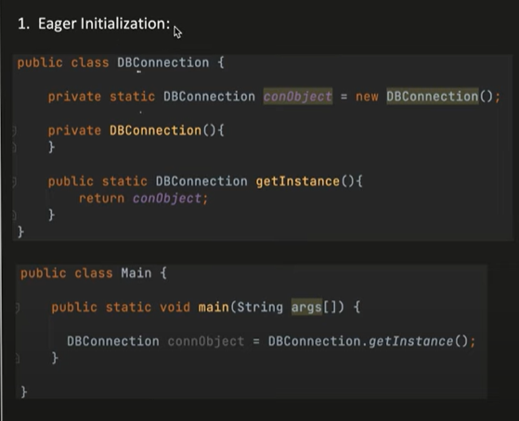

-Lazy

Whenever required for object creation, it is called

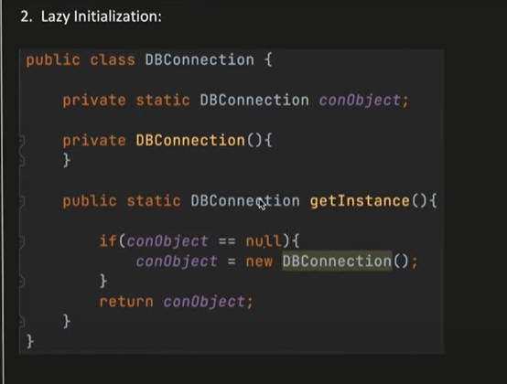

-synchronized

When two threads called using the method simultaneously, it can be locked using the synchronize keyword.

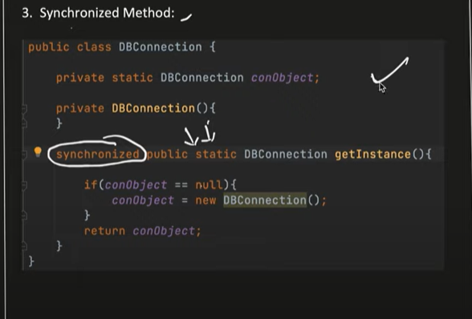

--Double Locking (It is widely used in the industry)

In synchronized pattern, thread will lock the method and all other threads will wait for it to use it.

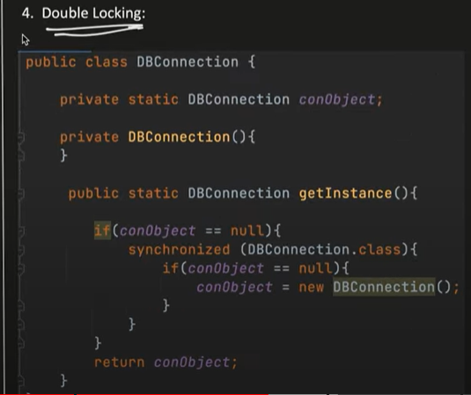

1. **Prototype Design Pattern:**

To create copy/clone from the existing objects.

Ex: For robot object it is expense to create another, then we can copy/clone that object.

Here student class, has to take care of the object assignment and not Main class.

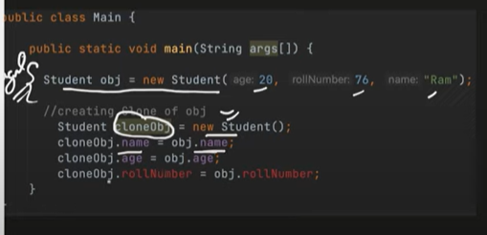

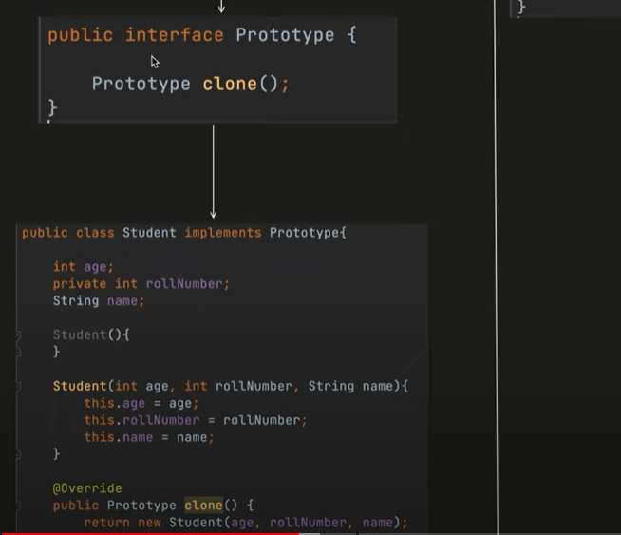

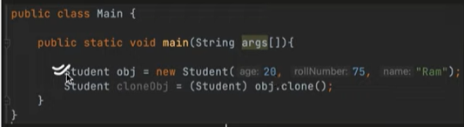

1. **Factory Design Pattern:**

It is used when all the object creation and its business logic we need to keep at one place.

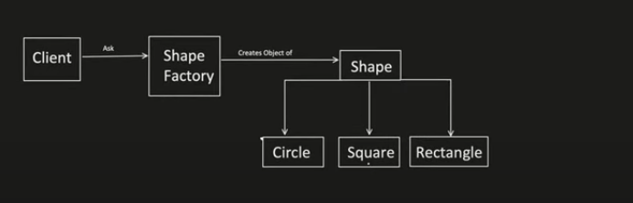

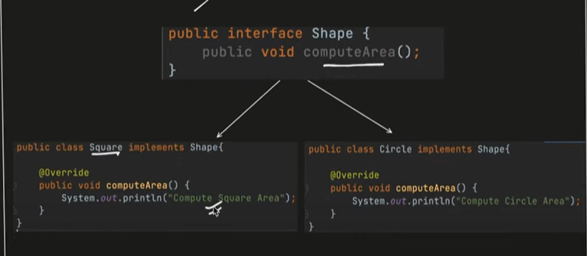

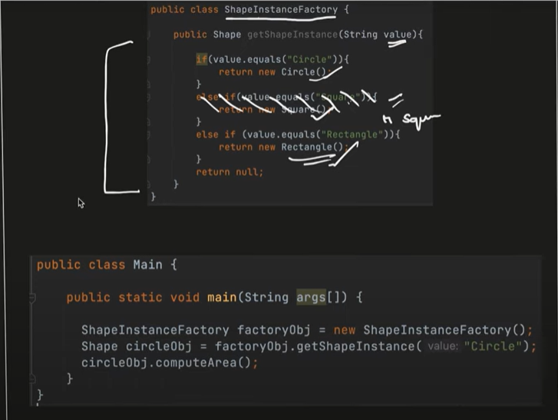

1. **Abstract Factory Design Pattern:**

It is factory of Factory.

Car interface can have multiple cars like economic car, premium car

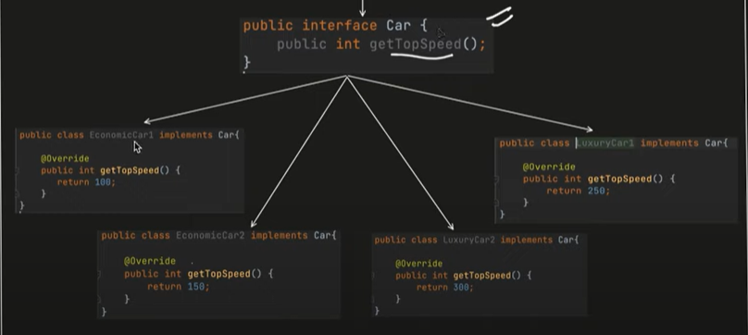

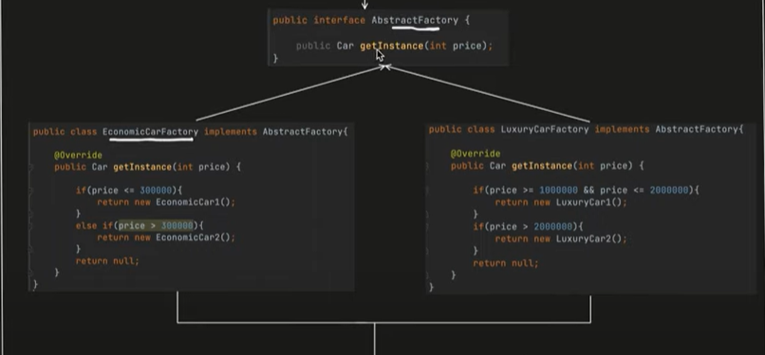

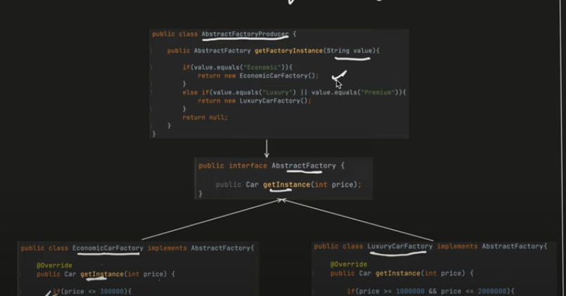

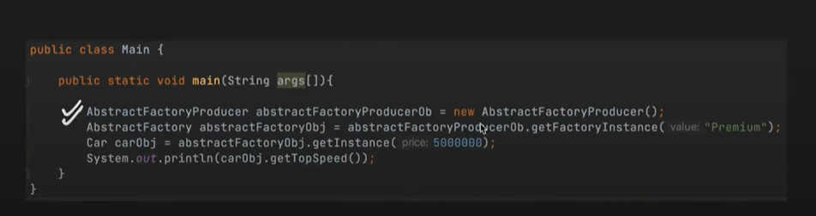

1. **Builder Design Pattern:**

To create objects step by step.

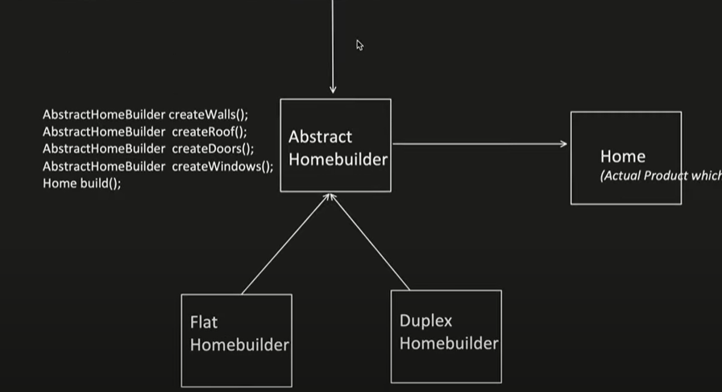

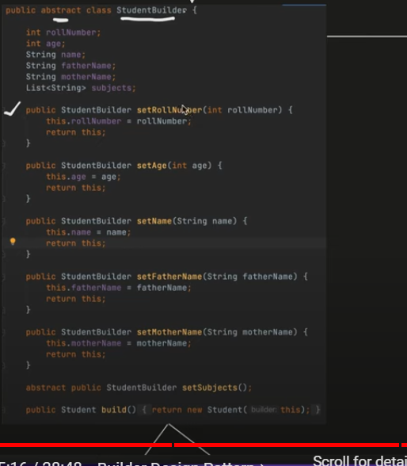

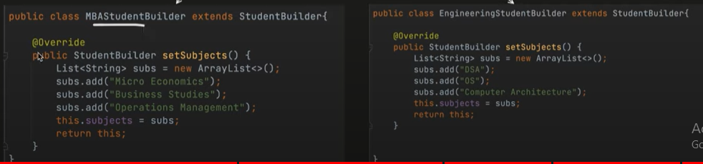

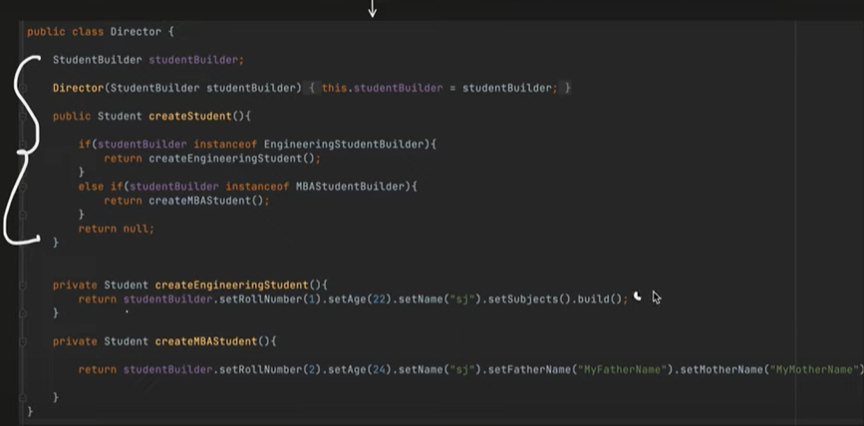

Git

1. Git init
2. Git branch –M main
3. Git add .
4. Git commit –m “comments”
5. Git remote add origin <https://github.com/MukeshRaj94/ReactJs.git>
6. Git push origin main

If new repo is created in the github, then by using the below cmd, we can use connect to the github from vs code,

* Git remote add origin [git@github.com:MukeshRaj94/NetflixGpt.git](mailto:git@github.com:MukeshRaj94/NetflixGpt.git)
* Git branch –M main
* Git push –u origin main

Node JS

1. Npm init
2. Npm install –D parcel => -D for development dependencies
3. It is recommended to commit both package-lock.json and package.json but not to commit node_modules.
4. Package.json – configuration file for NPM. Contains metadata about the project such as name, version, description and dependencies(dev/normal). It will be created after “npm init”

It is created and modified by developers.

1. Package-lock.json – It records the exact version of every installed dependency, including its sub-dependency versions. Earlier, when a project was deployed or shared with others, there was a risk that different developers or machines would use different versions of the same dependency, which could cause compatibility issues or unexpected behavior.

It is automatically generated by npm

1. Version – 2 is major version, 12 is minor version, 0 is patch version

"devDependencies": {

    "parcel": "^2.12.0"

  }

1. Tilde(~) – allows only patch update
2. Caret(^) – allows minor and patch update.
3. Npx parcel index.html – it will execute index.html into a bundler such as parcel

React JS

1. React js is a library and not a framework.
2. For to use react js in html, use the below code,

<script crossorigin src="https://unpkg.com/react@18/umd/react.development.js"></script>

<script crossorigin src="https://unpkg.com/react-dom@18/umd/react-dom.development.js"></script>

But this is not recommended way, use npm.

1. First Link id for core react. Second link is for connecting react with browser.
2. Crossorigin – when script on one domain is trying to fetch or interact with resources from another domain.
3. Root will be from ReactDOM and for creating element needs to use React.

const root = ReactDOM.createRoot(document.getElementById("root"));

const heading = React.createElement("h1",{},"Hello World Using React!");

root.render(heading);

1. Root.render – will replace the code and not appending.
2. React can work independently, even in small portion
3. “npm install react” – for installing react into project
4. “npm install react-dom” – for installing react-dom into project
5. Need to import react in App.js file,

import React from "react";

import ReactDOM from "react-dom";

And has to mention in the .html file, type=”module”, otherwise error will be thrown

<script type="module" src="./App.js"></script>

1. React app can be ignited by parcel,

“npx parcel index.html”

1. React app for prod can be done by,

“npx parcel build index.html”

1. For to support our app in particular browser, need to mention in the package.json

 "browserlist":[

    "last 2 versions"

  ]

1. For to start the project in development by writing in the script as follow,

In package.json,

"scripts": {

    "start": "parcel index.html",

    "build" : "parcel build index.html",

    "test": "jest"

  },

In terminal, use npm run start / npm start for starting the project.

1. JSX – JavaScript XML. HTML like or XML like syntax
2. Parcel uses Babel to convert JSX to javascript , so browser will understand.
3. React.createElement converts into js object and then to HTMLElement will render.
4. Attributes in JSX, has to be camelCase character.
5. React Component

Class Based Component – Older and mostly not using

Functional Component – Newer

Normal Function which is returning JSX is the functional component.

For to render it, needs to use “root.render(<HeadingComponent/>)”;

1. Passing props will be same as passing argument in function. For dynamic value, use this.
2. Config driven UI – Backend will take care which needs to show in UI.
3. In map, we need to use key attribute to uniquely identifies each element.
4. For export, use below,

export default Header;

export const CDN_URL = "https://media-assets.swiggy.com/swiggy/image/upload/fl_lossy,f_auto,q_auto,w_660/";

1. After export, use import in the file which required,

import Header from "./components/Header";

import { CDN_URL } from "../utils/constants";

1. Whenever state variables changes, react will re-render the component.
2. Hooks need to use inside function Component.

const Body = () => {

  const [filterRestaurant, setFilterRestaurant] = useState(resLis);

  console.log(filterRestaurant);

  return (

    <div className="body">

      <div className=

Otherwise, error will be thrown,

const [filterRestaurant, setFilterRestaurant] = useState(resLis);

const Body = () => {

return (

1. useState – used for variable which needs to be re-rendered(update) component again, so that new value gets refreshed.
2. useEffect – everytime my component renders, useEffect is called.

It contains two parameters, one is callback function which is mandatory and other is dependency array (not mandatory).

If no dependency array => useEffect is called on every rendering of component.

useEffect(() => {});

If dependency array is empty => useEffect is called on initial render(just once).

useEffect(() => {}, []);

If dependency array is available => useEffect is called everytime when dependency array changes.

useEffect(() => {

    console.log("useEffect Renders");

  }, [btnName]);

1. Conditional Rendering – Rendering happens with condition.

//Conditional Rendering

  if (filterRestaurant.length === 0) {

    return <Shimmer />;

  }

1. Shimmer – It is the fake effect of UI loading.
2. CORS plugin can be ignored and can use corsproxy infront of the api call.
3. For Routing to different pages, needs to instal react-router-dom

npm i react-router-dom

1. Rafce – shortcut for creating component skeleton.
2. For routing different pages, use the createBrowserRouter() method from react-router-dom,

const appRouter = createBrowserRouter([

  {

    path: "/",

    element: <AppLayout />,

  },

  {

    path: "/about",

    element: <About />,

  },

  {

    path: "/contact",

    element: <Contact />,

  },

]);

root.render(<RouterProvider router={appRouter} />);

1. useRouterError – For routing error as below,

 const err1 = useRouteError();

  console.log(err1);

  return (

    <div>

      <h1>Oops!!</h1>

      <h2>Something Went Wrong</h2>

      <h3>{err1.status}</h3>

    </div>

  );

const appRouter = createBrowserRouter([

  {

    path: "/",

    element: <AppLayout />,

    errorElement: <Errors />,

  },

1. For Outlet, It fills the path of the childer of AppLayout.

const AppLayout = () => (

  <div className="app">

    <Header />

    <Outlet />

  </div>

);

1. Link tag is the alternate to <a> tag, it loads only the component while <a> tag loads entire page.

<li>

            <Link to="/">Home</Link>

          </li>

          <li>

            <Link to="/about">About Us</Link>

          </li>

1. Class Component – class which returns JSX by render()

class UserClass extends React.Component {

  constructor(props) {

    super(props);

    console.log(props);

  }

  render() {

    return (

      <div className="user-card">

        <h1>Name : {this.props.name}</h1>

        <h2>Location: CHENNAI</h2>

        <h3>Contact: check</h3>

      </div>

    );

  }

}

For accessing variables, we need to use this keyword

     <UserClass name="Mukesh from About" />

1. In Class Component, state variables can be initialized by as follows,

 constructor(props) {

    super(props);

    this.state = {

      count: 5,

    };

  }

In order to change the state of the count variable,

<button

          onClick={() => {

            this.setState({

              count: this.state.count + 1,

            });

          }}

        >

1. Lifecycle of React Class based Component,

Constructor called

Render called

Component Mount called

1. In ComponentDidMount is used to make API calls,

Loads -> Render -> Api -> Render

1. Dynamic Bundling, Chunking, Code Splitting, Lazy Loading, On demand Loading, dynamic importing – all jargons refer same.

Consider, Swiggy internally loading Swiggy instamart which is a huge component and while loading it might takes sometime.

In order to avoid this, we are using lazy loading that huge component, so that no lagging will be there.

const Grocery = lazy(() => import("./components/Grocery"));

Here <Suspense> needs to be used, because it is loading another huge component and react will throw error if it is not used.

{

        path: "/grocery",

        element: (

          <Suspense>

            <Grocery />

          </Suspense>

        ),

      }

1. For tailwindcss, below command to install,

npm install -D tailwindcss

npx tailwindcss init

1. Refer <https://tailwindcss.com/docs/guides/create-react-app> for tailwind steps,
2. Higher Order Component : Takes component as input and enhances that component and returns that component.

export const withPromotedLabel = (RestaurantCard) => {

  return (props) => {

    return (

      <div>

        <label className="absolute bg-pink-50 m-4 p-2 rounded-lg">

          Promoted

        </label>

        <RestaurantCard {...props} />

      </div>

    );

  };};

1. React Developer tools extension needs to install in chrome.
2. Controlled Component – When Parent controls child
3. Uncontrolled Component – When Parent don’t controls child

Eg: Recommended Category in Swiggy app

1. UserContext is useful for to eliminate prop drilling, where child needs to use some props of parent of parent. Rather than passing one by one props to each step, we can use UserContext.

import { createContext, useContext } from "react";

const UserContext = createContext({

  loggedInUser: "Default User",

});

export default useContext;

1. UserContext needs to be wrapped in the App.js because it is global and accessible to all,

const AppLayout = () => {

  const [userName, setUserName] = useState();

  useEffect(() => {

    const data = {

      name: "Mukesh",

    };

    setUserName(data.name);

  }, []);

  return (

    <UserContext.Provider value={{ loggedInUser: userName, setUserName }}>

      <div className="app">

        <Header />

        <Outlet />

      </div>

    </UserContext.Provider>

  );

};

1. UserContext can be used in the other functional component as follows,

const { loggedInUser } = useContext(UserContext);

1. UserContext can be used in the Class based component as follows,

const About = () => {

  return (

    <div>

      About

      <UserContext.Consumer>

        {({ loggedInUser }) => {

          <h1>{loggedInUser}</h1>;

        }}

      </UserContext.Consumer>

      <UserClass />

    </div>

  );

};

export default About;

1. Unit testing – testing only particular unit for testing
2. Integration Testing – once integrated with other components, testing needs to perform.
3. React Testing library – builds on top of DOM testing library.
4. React testing library uses jest library

Npm I –D @testing-library/react

1. For Jest installation,

Npm I –D jest

1. Jest internally uses Babel. So babel needs to install,

npm i --save-dev babel-jest @babel/core @babel/preset-env

1. Babel config file needs to create,

Baebel.config.js

module.exports = {  
 presets: [['@babel/preset-env', {targets: {node: 'current'}}]],  
};

1. Parcel is internally using babel and config has been done earlier by parcel itself.

Now we are using jest for testing, which also internally uses babel, we need to manually write configuration in the .parcelrc

For disabling babel transformation can be done in the .parcelrc

1. Npm jest , when run this command it should show as below, so that our environment is good for running the test.

No tests found, exiting with code 1

Run with `--passWithNoTests` to exit with code 0

In D:\Project\ReactJs

32 files checked.

testMatch: **/__tests__/**/*.[jt]s?(x), **/?(*.)+(spec|test).[tj]s?(x) - 0 matches

testPathIgnorePatterns: \\node_modules\\ - 32 matches

testRegex: - 0 matches

Pattern: - 0 matches

1. Npx jest –init -> for executing jest

After executing this, some questions will be asked,

√ Would you like to use Typescript for the configuration file? ... no

√ Choose the test environment that will be used for testing » jsdom (browser-like)

√ Do you want Jest to add coverage reports? ... yes

√ Which provider should be used to instrument code for coverage? » babel

√ Automatically clear mock calls, instances, contexts and results before every test? ... yes

1. If we are using jest 28 and above, we need to install jsDOM separately. JsDOM is for environment to create a virtual DOM for to run test cases.
2. For jsDom to install,

npm install --save-dev jest-environment-jsdom

1. After installing jsDom, use npm test

It will show that no test cases are installed,

No tests found, exiting with code 1

Run with `--passWithNoTests` to exit with code 0

In D:\Project\ReactJs

33 files checked.

testMatch: **/__tests__/**/*.[jt]s?(x), **/?(*.)+(spec|test).[tj]s?(x) - 0 matches

testPathIgnorePatterns: \\node_modules\\ - 33 matches

testRegex: - 0 matches

Pattern: - 0 matches

1. _ _ dunder in js
2. Sample test format,

test("Description",()=>{

});

Instead of test , we can use the “it” keyword

test("Description of Contact", () => {

  render(<Contact />);

  const contact = screen.getByRole("heading");

  expect(contact).toBeInTheDocument();

});

1. Install @babel/preset-react to make jsx in test case
2. Include @babel/preset-react in babel config

["@babel/preset-react", { runtime: "automatic" }],

1. Install @testing-library/jest-dom
2. In the test class, if we use

getByRole – returns only one role

getAllByRole – returns multiple role

1. Describe used to group testcases,

describe("Contact us description of grouoping", () => {

  test("Description of Contact", () => {

    render(<Contact />);

    const contact = screen.getByRole("heading");

    expect(contact).toBeInTheDocument();

  });

  test("Description of Contact to check button", () => {

    render(<Contact />);

    const button = screen.getByRole("button");

    expect(button).toBeInTheDocument();

  });

});

1. Need to wrap this under Provider for using slice store, Browser for routing Link tag

it("With a Login Button", () => {

    render(

      <BrowserRouter>

        <Provider store={appStore}>

          <Header />

        </Provider>

      </BrowserRouter>

    );

    const login = screen.getByRole("button", { name: "Login" });

    expect(login).toBeInTheDocument();

  });

1. If we need to get the attributes, we can also use data-testid as follows,
2. For to create react app, using cmd with below codes,

npx create-react-app netflix-gpt

1. For Application which is huge with too many forms , we can use formic external library.
2. useRef hook -

<input

          className="p-4 my-4 w-full rounded-md bg-gray-800"

          type="text"

          placeholder="Email Address"

          ref={emailRef}

        />

        <input

          className="p-4 my-4 w-full rounded-md bg-gray-800"

          type="password"

          placeholder="Password"

          ref={passwordRef}

        />

const emailRef = useRef(null);

  const passwordRef = useRef(null);

  const handleValidation = () => {

    const message = validData(

      emailRef.current.value,

      passwordRef.current.value

    );

    setErrorMsg(message);

  };

1. Google Firebase – for backend and authentication
2. Needs to create project in the firebase. After create web project and do the process
3. Add firebase to the project using npm commands.

npm install firebase

1. Enable authentication for the project. Then only , registered user will be seen in the firebase.
2. Follow the commands for to host it in the firebase,

npm install -g firebase-tools

firebase login

firebase init

It will ask some questions, answer that

PS D:\Project\NetflixGpt> firebase init

######## #### ######## ######## ######## ### ###### ########

## ## ## ## ## ## ## ## ## ## ##

###### ## ######## ###### ######## ######### ###### ######

## ## ## ## ## ## ## ## ## ## ##

## #### ## ## ######## ######## ## ## ###### ########

You're about to initialize a Firebase project in this directory:

D:\Project\NetflixGpt

? Are you ready to proceed? Yes

? Which Firebase features do you want to set up for this directory? Press Space to select features, then Enter to confirm your

choices. Hosting: Configure files for Firebase Hosting and (optionally) set up GitHub Action deploys

=== Project Setup

First, let's associate this project directory with a Firebase project.

You can create multiple project aliases by running firebase use --add,

but for now we'll just set up a default project.

? Please select an option: Use an existing project

? Select a default Firebase project for this directory: netflixgpt-b8c0e (NetflixGpt)

i Using project netflixgpt-b8c0e (NetflixGpt)

=== Hosting Setup

Your public directory is the folder (relative to your project directory) that

will contain Hosting assets to be uploaded with firebase deploy. If you

have a build process for your assets, use your build's output directory.

? What do you want to use as your public directory? build

? Configure as a single-page app (rewrite all urls to /index.html)? No

? Set up automatic builds and deploys with GitHub? No

+ Wrote build/404.html

+ Wrote build/index.html

i Writing configuration info to firebase.json...

i Writing project information to .firebaserc...

+ Firebase initialization complete!

1. It will create firebase config file,
2. firebase deploy – to deploy in the firebase.
3. From the documentation use the code for creating user, sign in and other things,
4. After creating user and signed in , needs to store the user object in the redux store. So that it can be used anywhere else in the application.
5. For redux creation, use the below command,

npm i -D @reduxjs/toolkit

npm i react-redux

1. Create appstore.js

import { configureStore } from "@reduxjs/toolkit";

import userReducer from "./userSlice";

const appStore = configureStore({

  reducer: {

    user: userReducer,

  },

});

export default appStore;

1. Create slice.js,

import { createSlice } from "@reduxjs/toolkit";

const userSlice = createSlice({

  name: "user",

  initialState: null,

  reducers: {

    addUser: (state, action) => {

      return action.payload;

    },

    removeUser: (state) => {

      return null;

    },

  },

});

export default userSlice.reducer;

export const { addUser, removeUser } = userSlice.actions;

1. Need to provide store to the app,

import Body from "./components/Body";

import { Provider } from "react-redux";

import appStore from "./utils/appStore";

function App() {

  return (

    <Provider store={appStore}>

      <Body />

    </Provider>

  );

}

export default App;

1. After providing that, needs to add the event listener to the Body component, so whenever sign in , sign out happens it will call that. This event listener will be provided by firebase,
2. Needs to use the hook, useEffect because we will render after the component,

useEffect(() => {

    onAuthStateChanged(auth, (user) => {

      if (user) {

        // User is signed in, see docs for a list of available properties

        // https://firebase.google.com/docs/reference/js/auth.user

        const { uid, email, displayName } = user;

        dispatch(addUser({ uid: uid, email: email, displayName: displayName }));

      } else {

        dispatch(removeUser());

      }

    });

  }, []);

1. Inorder to update the profile,

updateProfile(user, {

            displayName: name.current.value,

          })

            .then(() => {

              const { uid, email, displayName } = user;

              dispatch(

                addUser({ uid: uid, email: email, displayName: displayName })

              );

              navigate("/browse");

            })

            .catch((error) => {

              setErrorMsg(error);

            });

1. useNavigate hook to navigate to the certain page,

const navigate = useNavigate();

navigate("/browse");

1. In the useEffect, if we need to unmount that event listerner, then it has to return the function,

useEffect(() => {

    const unsubscribe = onAuthStateChanged(auth, (user) => {

      if (user) {

        // User is signed in, see docs for a list of available properties

        // https://firebase.google.com/docs/reference/js/auth.user

        const { uid, email, displayName } = user;

        dispatch(addUser({ uid: uid, email: email, displayName: displayName }));

        navigate("/browse");

      } else {

        dispatch(removeUser());

        navigate("/");

      }

    });

    return () => unsubscribe();

  }, []);

1. TMDB provides the updated movie and we can use the latest movies
2. Inorder ot use the api, first sign up and login and got to edit profile and click API.
3. There regsister the app and go to documentation and get the now playingMovies api.
4. When we use React.StrictMode, in the console.log it will be print two times. This is because, it is making sure that the component is rendered properly, so it is rendering two times.

<React.StrictMode>

    <App />

  </React.StrictMode>

1. In jsx, the params has to follow the camelCase.
2. useSelector is to get the value from the redux store.
3. Inorder to use OpenAi, we need api key. For that login into openAi and get it.
4. This api will be free for 3months.
5. After that install openai in our projectusing below commands,

npm install openai